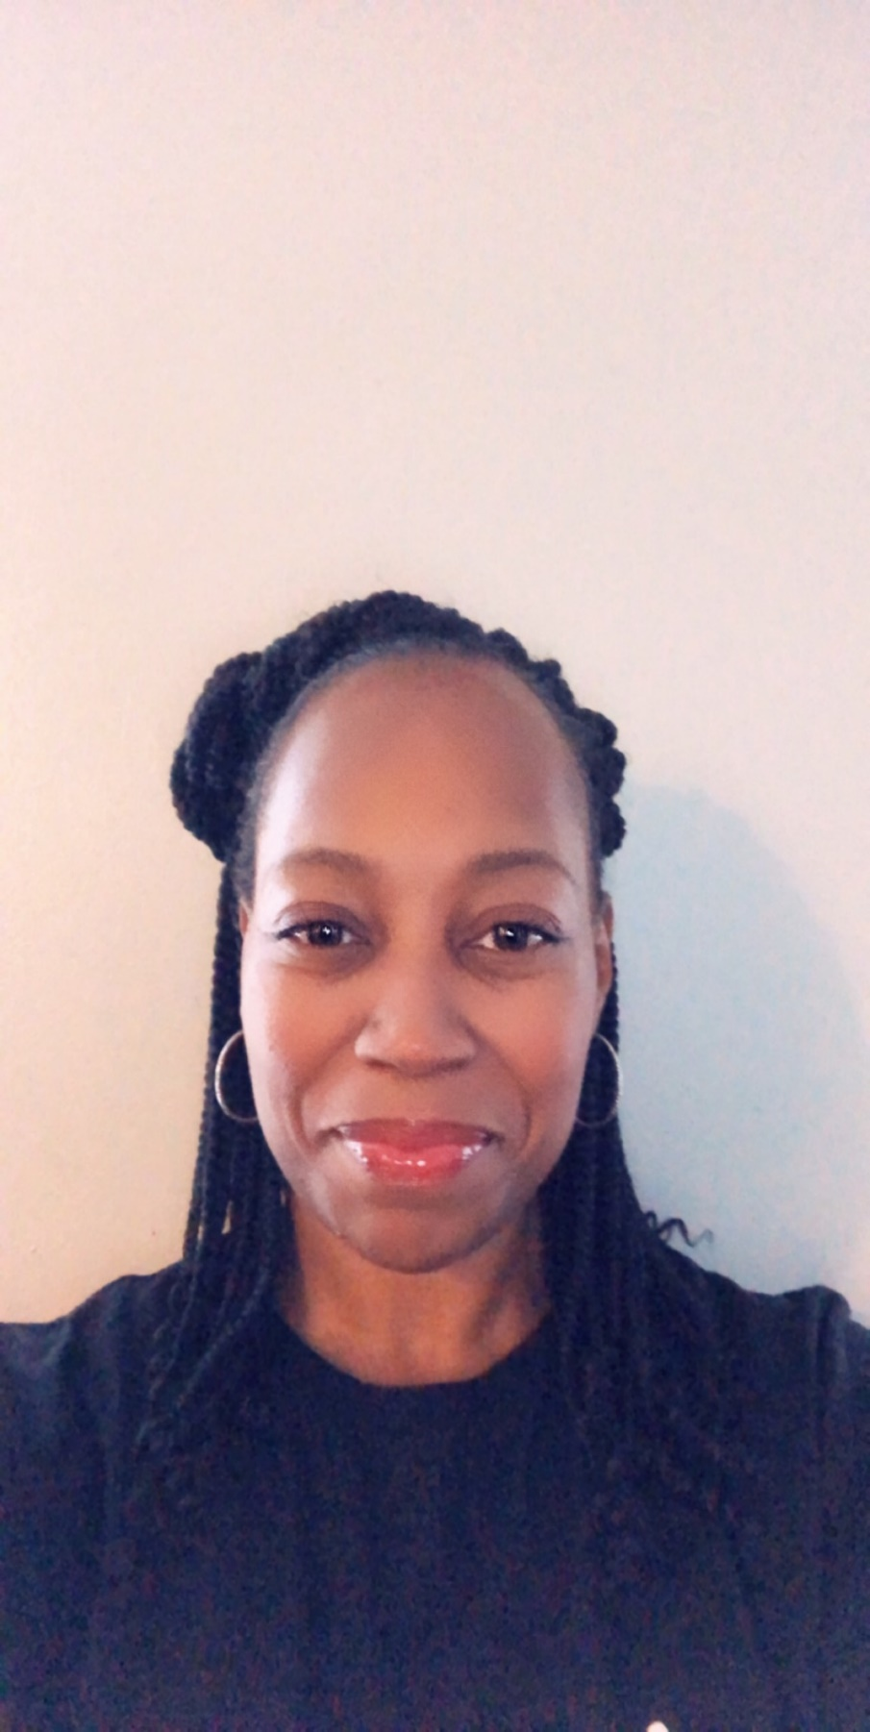

Shamarah is a certified STRONG by Zumba and Group Exercise instructor. Her passion for helping woman to achieve their fitness goals and live a healthier lifestyle comes from her own personal life journey. Shamarah is married with four children, and has experienced health challenges such as high blood pressure and obesity. Shamarah understands the challenges woman experience while trying to balance family and everyday life! She had to take the first step and say, “I am ready to change my life in order to save my life”, making a commitment to herself to change her diet and exercise. She has lost over 40 lbs. with her lifestyle changes and no longer has high blood pressure. She also has her Master’s of Science in Human Resources Management from the University of Concordia. Shamarah believes that “The struggle you are in today is developing the strength you need for tomorrow and the rest of your life”. She will encourage you to stay committed to the process and to help you reach your fitness goals and aspirations.

